1. What is jQuery?

* jQuery is a lightweight, "write less, do more", JavaScript library.
* The purpose of jQuery is to make it much easier to use JavaScript on your website.
* jQuery takes a lot of common tasks that require many lines of JavaScript code to accomplish, and wraps them into methods that you can call with a single line of code.

1. How to Apply CSS Using JQuery, How to Add Class and Remove Class in Jquery , JQuery Animation?

* addClass() - Adds one or more classes to the selected elements.
* removeClass() - Removes one or more classes from the selected elements.

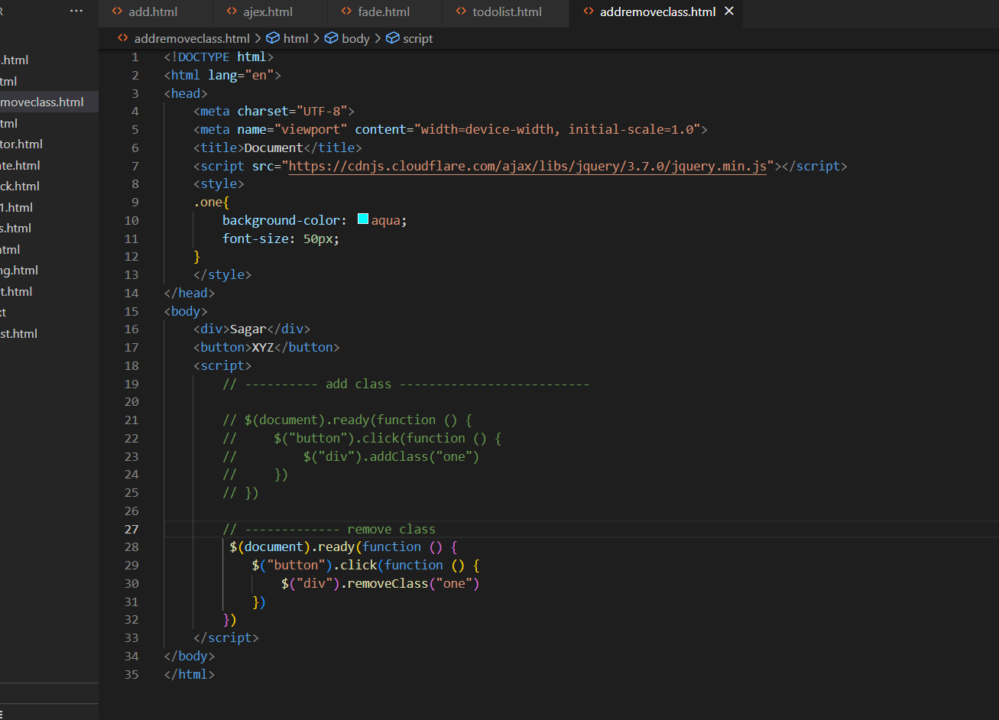

1. how to create slider with animation ?

* $(selector).slideToggle(speed,callback);



    
    
    